Experiment 0: Sensor Calibration and Linear Regression

Amanda Wei

505106664

04/09/2019

Thursday 8am

Steve Mendoza

1. Cover page
2. $士\sqrt{{(\frac{δ∆v}{∆v})}^{2}+{(\frac{δ∆t}{∆t})}^{2}}$ is the propagated uncertainty
3. Capstone displays a maximum of 18 digits. If the sensor precision is 4 digits, then that is the measurement precision and digits 5-10 measure uncertainty in the data. Precise measurements will yield small fluctuations in the digits, while distributed data will show up as greater fluctuations. If sensor fluctuations are completely eliminated, then the data may display quantization error, which is where valuable information about the precision of the data is omitted by truncating too many digits. It will not give a useful sense of the precision of the data.
4. 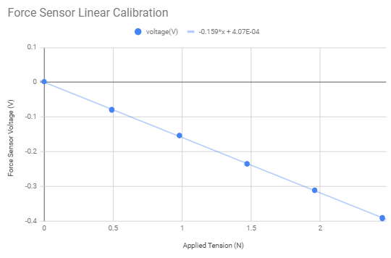 This graph displays the voltage detected by the force sensor as a function of the tension applied to the hook by the various weights attached to the hook.
5. After calibration, when force was set to 0, there was a detected voltage of 4.07 ${10}^{-4}$ $±0.00093V$\*. This indicates that after ten trials, the average detected voltage after being tared was 4.07 ${10}^{-4}$\*V, the nonzero y-intercept, with a standard deviation of 0.00093V. This shows that while taring the instrument can only minimize error, but it is never precisely zero and may affect data. The large error can be accounted for by relatively large deviation from the line of best fit, which is likely the result of statistical errors.
6. To get the calibration curve in the form $F = cV + d$, we invert the line of best fit to get $F=-6.289V+0.00256$ N, where the uncertainty in the slope is 土0.00025 N, while the uncertainty in the y-intercept is 土0.023 N. This was done by taking the original uncertainty values in their percentage form, inverting the function, and then adding the new uncertainties correspondingly to their percentages.
7. This is possible because the two students performed differently when compared to how other students in their class did. The class average in Frankie’s class must have been lower, so Frankie did relatively well and received a B+. Avril did poorly compared to the other students in her class so the average was likely higher and so she got curved down to a C+.